Design a doorbell using push button.

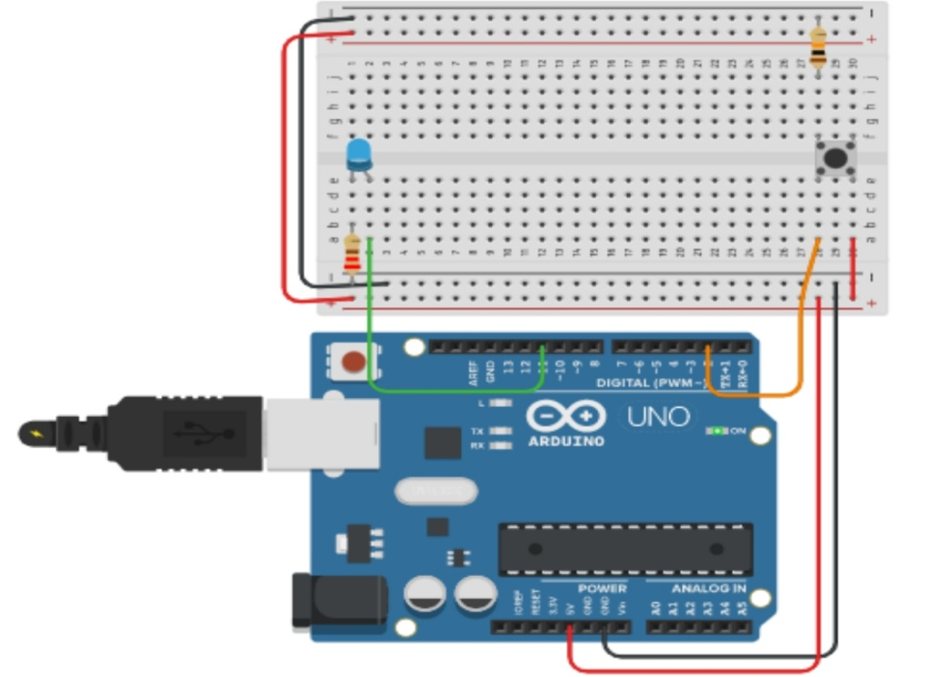

THEORY

Concept used :- we have build this diagram on the bases of simple led on off system

Learning and observation:- how to make door bell

Problem and troubleshooting:- the buzzer was not ringing well so we change the buzzer

Precaution :- do not lose the connection connect it properly

Learning and outcome:- we can make alarm system